
CyberSkills
ARTIFICIAL INTELLIGENCE – SPECIALISMS
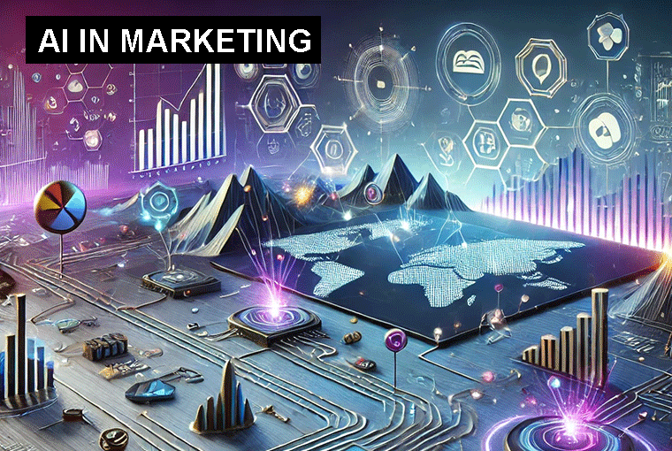  Duration: 3-Days  Access: 180-days  Price: £279.00 + VAT  Includes: ChatGPT Prompts for  Marketers  Outcome: Completion Certificate  following the successful completion  of 11 quizzes | Contents:  - Introduction to AI in Marketing  - Prompting for Marketers  - Email Marketing  - Affiliate Marketing  - Social Media Marketing  - Market Research  - PPC Marketing  - Public Relations  - Storytelling in Marketing  - Search Engine Optimisation  - Influencer Marketing  - How to Make an AI Influencer  - AI in Packaging Design  - Use AI to Design Professional Brands  - Capstone Project: AI-Powered Marketing Strategy and Solution

AI IN MARKETING
AI is transforming the field of marketing by enabling businesses to analyze data more effectively, personalize customer experiences, optimize campaigns, and automate various marketing processes.
AI enhances marketing by enabling more accurate customer segmentation, personalized messaging, and real-time optimizations that improve the effectiveness of marketing campaigns. From predictive analytics to dynamic pricing and chatbots, AI drives smarter decision-making, reduces manual workload, and delivers better customer experiences. By leveraging AI, marketers can streamline operations, improve ROI, and gain a competitive edge in a rapidly evolving digital landscape.
Course Objectives
- Provide Comprehensive Knowledge: Equip you with a solid understanding of how AI intersects with marketing.
- Develop Practical Skills: Enable you to apply prompting techniques to real-world marketing challenges.
- Foster Critical Thinking: Encourage you to consider the ethical, legal, and practical implications of AI in marketing.
- Prepare for the Future: Highlight emerging trends to keep you ahead in the evolving AI in marketing landscape.

  Length: 1-Day  Access: 90-days  Price: £199.00 + VAT  Outcome: Completion Certificate  following the successful completion  of 6 quizzes | Contents:  - Introduction to AI in Banking & Finance  - The Current Landscape of AI in Financial Services  - AI Technologies & Tools for Banking & Finance  - Practical Use Cases & Interactive Exercises  - Ethical, Security & Regulatory Considerations  - Future Trends & Innovations in AI for Finance  - Leveraging Microsoft Co-Pilot  - Prompts for Banking & Finance  - Course Summary & Next Steps
AI IN BANKING & FINANCE
Banks leverage AI to automate routine tasks—like document processing, data entry, and transaction monitoring—reducing manual labor and error rates. As a result, financial institutions can handle larger volumes of transactions more quickly and accurately.
This course ensures a comprehensive journey from foundational AI knowledge to specialized applications in banking & finance, culminating with practical labs and forward-looking insights.
Microsoft Co-Pilot is used throughout the course exercises with suggested prompts for each section of the course. In addition, the ‘Prompts for Banking and Finance’ section provides prompts that cover 9 areas of the Banking and Finance sector.
Course Objectives:
- Provide Comprehensive Knowledge: Equip you with a solid understanding of how AI intersects with banking & finance.
- Develop Practical Skills: Enable you to apply machine learning techniques to real-world banking & finance challenges.
- Foster Critical Thinking: Encourage you to consider the ethical considerations of AI in banking & finance.
- Prepare for the Future: Highlight emerging trends to keep you ahead in the evolving AI in banking & finance landscape.

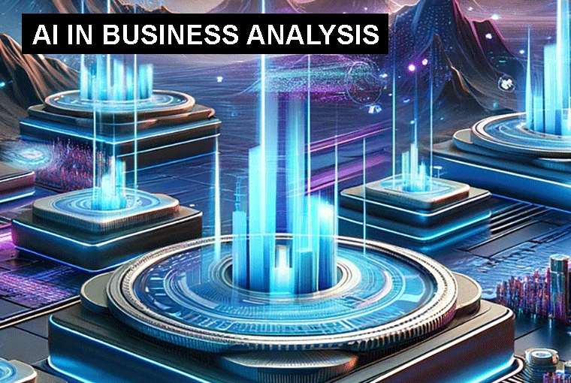  Length: 1-Day  Access: 90-days  Price: £199.00 + VAT  Outcome: Completion Certificate  following the successful completion  of 10 quizzes | Contents:  - Introduction to AI in Business Analysis  - Core AI Technologies for Business Analysis  - Data Handling and Preprocessing for AI  - Predictive Analytics and Forecasting with AI  - AI for Customer Segmentation and Behavioral Analysis  - AI-Driven Decision-Making in Business  - Automation of Business Processes Using AI  - Natural Language Processing (NLP) for Text Analysis in Business  - AI-Enhanced Data Visualization and Reporting  - Ethical Considerations and Limitations of AI in Business  - Capstone Project: AI-Powered Business Solution  - Prompts for Business Analysis

AI IN BUSINESS ANALYSIS
In today’s rapidly evolving business environment, Artificial Intelligence (AI) is transforming the way organizations analyze data, make decisions, and optimize operations. The introduction of AI into business analysis provides companies with the tools to extract deeper insights, automate processes, and predict future trends.
AI is revolutionizing business analysis by providing deeper insights, automating manual processes, and enabling data-driven decision-making. As AI technology continues to advance, its role in business analysis will only grow, offering even more transformative benefits for organizations across industries.
Course Objectives:
- Provide Comprehensive Knowledge: Equip you with a solid understanding of how AI intersects with business analysis.
- Develop Practical Skills: Enable you to apply machine learning techniques to real-world business analysis challenges.
- Foster Critical Thinking: Encourage you to consider the ethical considerations of AI in business analysis.
- Prepare for the Future: Highlight emerging trends to keep you ahead in the evolving AI in business analysis.

  Length: 1-Day  Access: 90-days  Price: £199.00 + VAT  Outcome: Completion Certificate  following the successful completion  of 10 quizzes | Contents:  - Introduction to AI in Project Management  - AI for Project Planning and Scheduling  - AI for Risk Management  - AI for Project Monitoring and Performance Tracking  - AI for Resource and Budget Management  - AI for Task Automation and Workflow Management  - AI in Agile Project Management  - AI for Stakeholder Communication and Reporting  - Ethical and Regulatory Considerations in AI-Powered Project Management  - Case Studies: AI in Real-World Project Management  - Capstone Project: AI-Enhanced Project Management Solution  - Prompts for Project Startup  - Prompts for Managing a Project
AI IN PROJECT MANAGEMENT
As businesses face increasing complexity and the demand for faster, more efficient project execution, Artificial Intelligence (AI) has emerged as a game-changer in project management. AI technologies can automate routine tasks, provide data-driven insights, enhance decision-making, and help project teams achieve better outcomes. In this course, we will explore the foundational concepts of AI, its role in project management, the key benefits it offers, and some popular AI-powered tools used in the field.
AI is transforming project management by automating mundane tasks, providing actionable insights, and improving decision-making processes. By leveraging AI, project managers can boost efficiency, enhance collaboration, mitigate risks, and ensure better project outcomes. As AI tools become more integrated into project management platforms, understanding how to effectively use these technologies will be critical for project success in the future.
Course Objectives:
- Provide Comprehensive Knowledge: Equip you with a solid understanding of how AI intersects with project management.
- Develop Practical Skills: Enable you to apply machine learning techniques to real-world project management challenges.
- Foster Critical Thinking: Encourage you to consider the ethical considerations of AI in project management.
- Prepare for the Future: Highlight emerging trends to keep you ahead in the evolving AI in project management landscape.

  Length: 1-Day  Access: 90-days  Price: £199.00 + VAT  Outcome: Completion Certificate  following the successful completion  of 10 quizzes | Contents:  - Introduction to AI in Change Management  - Understanding Organizational Change and AI's Role  - AI-Driven Change Strategy Development  - AI for Communication and Engagement during Change  - AI for Monitoring and Measuring Change Progress  - AI in Risk Management during Change  - AI for Automating Change Processes  - AI-Enhanced Leadership during Change  - Ethical Considerations in AI-Driven Change Management  - Case Studies and Applications of AI in Change Management  - Capstone Project: AI in Change Management Strategy  - Prompts for Change Management
AI IN CHANGE MANAGEMENT
Organizational change is a necessary process for companies to stay competitive, adapt to new market conditions, and embrace innovations. However, managing change effectively requires a structured approach to ensure that transitions are smooth, employees are engaged, and organizational goals are met. In recent years, Artificial Intelligence (AI) has emerged as a powerful tool for enhancing change management efforts, offering predictive insights, automation, and improved decision-making processes. In this course, we will explore the basics of change management, the role AI plays in facilitating these processes, and the key benefits AI brings to change management.
AI is transforming the field of change management by providing organizations with faster, more accurate, and data-driven tools to manage complex transitions. By leveraging AI’s ability to analyze data, predict outcomes, and automate processes, organizations can optimize their change initiatives, reduce resistance, and improve overall success rates. As the role of AI in change management continues to grow, businesses will be better equipped to navigate the challenges of organizational transformation with greater confidence and efficiency.
Course Objectives:
- Provide Comprehensive Knowledge: Equip you with a solid understanding of how AI intersects with change management.
- Develop Practical Skills: Enable you to apply machine learning techniques to real-world change management challenges.
- Foster Critical Thinking: Encourage you to consider the ethical considerations of AI in change management.
- Prepare for the Future: Highlight emerging trends to keep you ahead in the evolving AI in change management landscape.

  Length: 1-Day  Access: 90-days  Price: £199.00 + VAT  Outcome: Completion Certificate  following the successful completion  of 10 quizzes | Contents:  - Introduction to AI in Cyber Security  - Fundamentals of Cyber Security  - Machine Learning Techniques in Cyber Security  - AI-Powered Threat Detection  - AI in Incident Response and Management  - Challenges and Limitations of AI in Cyber Security  - Ethical and Legal Considerations  - Future Trends and Emerging Technologies  - Hands-On Labs and Practical Exercises  - Conclusion and Next Steps  - Prompts for Cyber Security

AI IN CYBER SECURITY
AI and ML have become critical components in modern cyber security strategies due to their ability to process vast amounts of data and identify patterns that may indicate security threats.
Understanding these techniques equips cyber security professionals with the tools to implement AI-driven solutions that can adapt to evolving threats. By leveraging machine learning, organizations can enhance their detection, prevention, and response strategies, making their security posture more robust and proactive.
Course Objectives:
- Provide Comprehensive Knowledge: Equip you with a solid understanding of how AI intersects with Cyber Security.
- Develop Practical Skills: Enable you to apply machine learning techniques to real-world security challenges.
- Foster Critical Thinking: Encourage you to consider the ethical, legal, and practical implications of AI in Cyber Security.
- Prepare for the Future: Highlight emerging trends to keep you ahead in the evolving Cyber Security landscape.

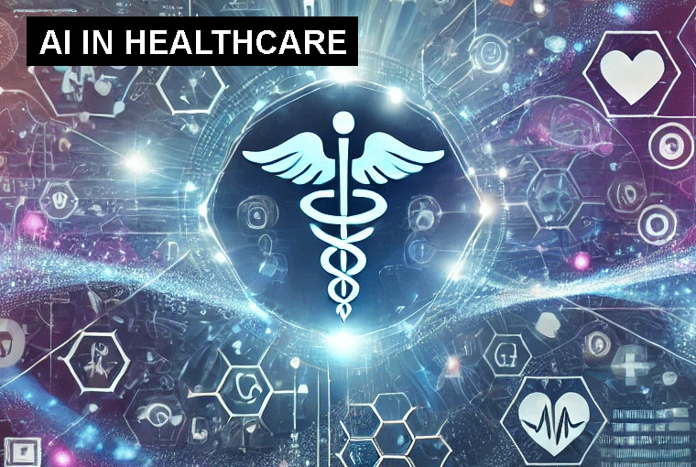  Length: 1-Day  Access: 90-days  Price: £199.00 + VAT  Outcome: Completion Certificate  following the successful completion  of 10 quizzes | Contents:  - Introduction to AI in Healthcare  - AI for Diagnostics and Medical Imaging  - AI in Precision Medicine and Personalized Treatment  - Natural Language Processing (NLP) in Healthcare  - AI for Predictive Healthcare and Risk Management  - AI in Clinical Decision-Making and Treatment Optimization  - AI in Healthcare Operations and Management  - AI for Telemedicine and Remote Healthcare  - Ethical and Regulatory Considerations in AI for Healthcare  - Case Studies: AI in Healthcare  - Capstone Project: AI-Powered Healthcare Solution  - Prompts for Healthcare

AI IN HEALTHCARE
Artificial Intelligence (AI) is transforming the healthcare industry, offering powerful tools that enhance diagnostic accuracy, streamline treatment, and improve patient outcomes. By applying AI, healthcare professionals can leverage large volumes of data to make informed, data-driven decisions that personalize care, optimize operations, and enhance clinical efficiency. In this course, we will introduce the key concepts of AI, explore its importance in healthcare, examine the key AI technologies currently in use, and identify emerging trends that are shaping the future of healthcare.
AI is transforming healthcare in unprecedented ways, from improving diagnostic accuracy to revolutionizing patient care through personalized treatments. By leveraging key technologies like machine learning, NLP, and predictive analytics, AI is enabling healthcare providers to deliver more precise, efficient, and accessible care. As AI continues to evolve, trends like AI-driven telemedicine, robotic surgery, and personalized medicine will further enhance the way healthcare is delivered, making it more proactive, patient-centered, and efficient.
Course Objectives:
- Provide Comprehensive Knowledge: Equip you with a solid understanding of how AI intersects with healthcare.
- Develop Practical Skills: Enable you to apply machine learning techniques to real-world healthcare challenges.
- Foster Critical Thinking: Encourage you to consider the ethical, legal, and practical implications of AI in healthcare.
- Prepare for the Future: Highlight emerging trends to keep you ahead in the evolving AI in healthcare landscape.

  Length: 1-Day  Access: 90-days  Price: £199.00 + VAT  Outcome: Completion Certificate  following the successful completion  of 10 quizzes | Contents:  - Introduction to AI in Education  - AI-Powered Personalized Learning  - AI for Student Assessment and Feedback  - AI in Educational Content Creation  - AI in Student Support and Engagement  - AI in Administrative Efficiency  - AI for Teacher Support and Professional Development  - Ethical Considerations and Challenges in AI-Driven Education  - AI for Special Education and Inclusion  - AI in Lifelong Learning and Professional Training  - Capstone Project: Designing an AI-Powered Educational Solution  - Future Trends and Innovations in AI for Education  - Prompts for Education

AI IN EDUCATION
Artificial Intelligence (AI) refers to the simulation of human intelligence in machines that are designed to think, learn, and make decisions. AI systems use algorithms and large datasets to analyze information, recognize patterns, and solve problems. AI technologies include machine learning (ML), natural language processing (NLP), computer vision, and robotics, among others. In the context of education, AI has the potential to revolutionize learning by automating processes, personalizing instruction, and enhancing student outcomes through data-driven insights.
AI is rapidly transforming education by enhancing personalization, streamlining administrative tasks, and providing data-driven insights that improve both teaching and learning outcomes. However, to fully harness AI’s potential, it is essential to address ethical concerns such as data privacy, bias, and accessibility. As AI continues to evolve, its role in education will expand, creating new opportunities for students, educators, and institutions worldwide.
Course Objectives:
- Provide Comprehensive Knowledge: Equip you with a solid understanding of how AI intersects with education.
- Develop Practical Skills: Enable you to apply machine learning techniques to real-world education challenges.
- Foster Critical Thinking: Encourage you to consider the ethical, legal, and practical implications of AI in education.
- Prepare for the Future: Highlight emerging trends to keep you ahead in the evolving AI in education landscape.

